aim games  
Sprint 3 review

# Summons

|  |  |
| --- | --- |
| Name | Roll |
| De la Fuente Bonilla, Fco. Javier | **CEO, Project manager** |
| Molina Domínguez, Jorge Manuel | **CCO,CIO** |
| Bizcocho González, Mario | **CMO, Product Owner** |
| Arenas Arenas, Antonio  Monteseirín Puig, Alejandro  Pazo Jiménez, Pablo  Pérez Piñero, Iván  Santos Batista, Miguel | **Developers** |

# attendee

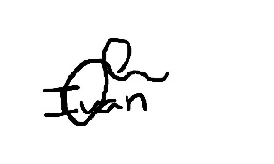**De la Fuente Bonilla, Fco. Javier Pérez Piñero, Iván**

**Arenas Arenas, Antonio Molina Domínguez, Jorge Manuel**

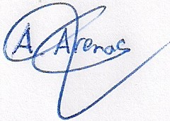

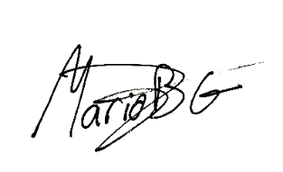**Monteseirín Puig, Alejandro Bizcocho González, Mario**

**Santos Batista, Miguel Pazo Jiménez, Pablo**

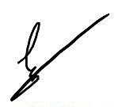

# Absent

No Proceed

# Date and place

Being on Friday April 26, 2019, and verified the attendance of all the summoned, began at 11:15 hrs. To the Sprint review meeting for the AIM GAMES project, which ended at 12:30 hrs.

# AGENDA

1º Review of things created to date and discuss problems that have showed up

# Development of the meeting and agreements

## Review of things created to date and discuss problems that have showed up

During the meeting there was a discussion about how the sprint was going and the biggest problems that were encountered in terms of organization and development.

The main problems were the lack of communication and low work invested in the project to date.

We have compromised to work hard during the weekend and rest of the sprint, now that we have not more exams, so we will have something done and finished for the following up of the next Monday at SEPP class.

# Signed in conformity

